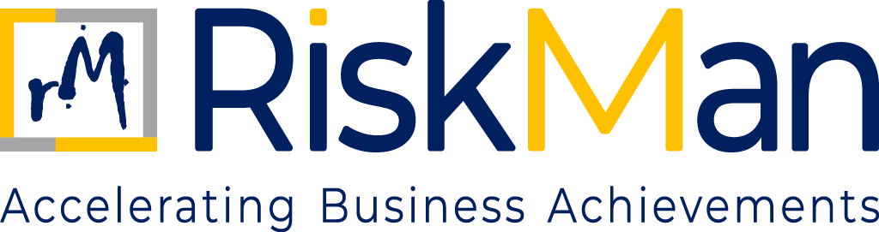
CORPORATE GOVERNANCE POLICY
TABLE OF CONTENTS
Corporate Governance Policy

- Objective…………………………………………………………………….……………………………………………………………3
- Scope and Applicability……………………………….……………………………………………………………………………3
- Governance Approach……………………………………………………………………………………………………………..3
- Governance Structure………………………………………………………………………………………………………………3
- Roles and Responsibilities………………………………………………………………………………………………………..4
- Decision Making ……………………………………………………………………………………………………………………..4
- Ethical Governance………………………………………………………………………………………………………………….5
- Risk and Compliance Oversight……………………………………………………………………………………………….5
- Transparency and Disclosure…………………………………………………………………………………………………..5
- Monitoring and Performance Review……………………………………………………………………………………..5
- Training and Awareness………………………………………………………………………………………………………….5

CORPORATE GOVERNANCE POLICY
- OBJECTIVE

The objective of this Corporate Governance Policy (“Policy”) is to establish a comprehensive, structured, and enforceable governance framework for RiskMan Consulting LLP (“RiskMan” or “the Firm”).
This Policy is intended to ensure:

- Effective leadership and strategic oversight
- Clear accountability and decision-making authority
- Ethical, transparent, and compliant conduct of business
- Protection of the interests of Partners, clients, employees, and regulators

The Policy supports the long-term sustainability, professional credibility, and regulatory compliance of the Firm.

- SCOPE

This policy applies to all individuals and entities associated with RiskMan Consulting LLP. It covers all employees, including those who are permanent, contractual, or interns, as well as partners, consultants, and associates who are professionally engaged with the Firm. Additionally, the policy extends to clients, suppliers, vendors, and any other third-party stakeholders who interact with or are connected to the operations and business activities of RiskMan in any capacity.

- GOVERNANCE APPROACH

RiskMan’s governance philosophy is founded on the following core principles:
- Integrity and ethical leadership
- Transparency and accountability
- Prudent risk management
- Compliance with applicable laws, regulations, and professional standards
- Responsible stewardship of the Firm’s reputation and resources
The Firm recognises that strong governance is essential to maintaining client trust, regulatory confidence, and sustainable growth.
- GOVERNANCE STRUCTURE

4.1 Partner-Led Governance Model
RiskMan operates under a Partner-led governance model. Ultimate authority and responsibility for the management, direction, and conduct of the Firm rests with the Partners.
4.2 Management Structure
The Partners may delegate operational responsibilities to senior management, subject to:
- Clearly defined authority limits
- Ongoing oversight by the Partners
Delegation shall not dilute the accountability of the Partners for the governance of the Firm.
4.3 Committees and Oversight Mechanisms
Where appropriate, the Partners may constitute committees or designate responsible individuals for oversight of specific areas, including but not limited to:
- Risk management
- Compliance and ethics
- Quality and independence
- Information and cyber security

- ROLES AND RESPONSIBILITIES
5.1 Responsibilities of Partners
The Partners are collectively responsible for:
- Setting the strategic direction of the Firm
- Approving governance frameworks, policies, and key decisions
- Defining and approving the Firm’s risk appetite
- Ensuring ethical conduct and compliance with applicable laws and professional standards
- Overseeing the performance of senior management
- Addressing material governance, risk, and compliance issues
5.2 Responsibilities of Senior Management and Engagement Leaders
Senior management is responsible for:
- Implementing Partner-approved strategies, policies, and decisions
- Managing day-to-day operations within delegated authority
- Identifying and escalating material risks, issues, or breaches
- Providing accurate and timely information to the Partners

- DECISION-MAKING

All material decisions relating to:

- Strategy and business direction
- Financial commitments and expenditures
- Client acceptance or termination
- Risk exposure and mitigation
- Regulatory or legal matters
- Reputational considerations

Shall be taken in accordance mutual discussion among the partners and senior management.

- ETHICAL GOVERNANCE
The governance framework of RiskMan reinforces strict adherence to:
- The Code of Conduct
- The Code of Ethics; and
Ethical considerations shall be an integral part of all strategic, operational, and client-related decisions. The Firm adopts a zero-tolerance approach towards unethical or unlawful conduct.
- RISK AND COMPLIANCE OVERSIGHT
The Partners shall ensure that:
- Material business, operational, regulatory, and reputational risks are identified and assessed
- Appropriate risk mitigation measures are implemented
- Compliance with applicable laws and professional standards is monitored
- Significant risk or compliance issues are escalated and addressed in a timely manner

- TRANSPARENCY AND DISCLOSURE
RiskMan shall maintain appropriate transparency in governance-related matters, including:
- Public disclosure of governance principles on its website, where appropriate
- Clear internal communication of governance expectations
- Confidential or sensitive information shall be disclosed only where legally required or professionally appropriate.

- MONITORING AND PERFORMANCE REVIEW
The effectiveness of the governance framework shall be reviewed periodically by the Partners, including:
- Assessment of governance practices
- Evaluation of compliance with this Policy
- Identification of areas for improvement
Corrective actions shall be implemented where deficiencies are identified.
- TRAINING AND AWARENESS
Relevant personnel shall be made aware of this Policy through induction processes, periodic governance, compliance, or ethics communications and training initiatives.

